Friendship and resilience
Fr Andrew Hamilton SJ | 15 July 2020

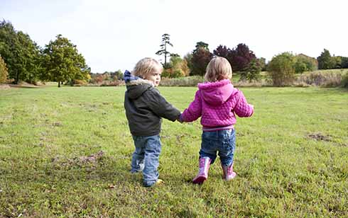
In future 2020 will be remembered by many different names. In Australia, one of them could well be the Year of Hard Times and Places.
We think of the country alight, of the people caught by coronavirus, and of the hardship suffered as a result of the isolation that followed it. 2020 will certainly not be called the year of trivial pursuits.
St Ignatius, whose feast day is 31 July, spent much of his life drawing people beyond trivial pursuits, and became at home in hard places.
He had to convalesce after being wounded in battle. He begged his way around Spain, slept rough, had constant run-ins with authorities suspicious of his faith and morals, went back to school in his late 20s, begged his way to visit the Holy Land but was ordered home, and faced every obstacle in placing himself and his friends at the disposal of the Pope. For much of his life, too, he suffered the acute pain of kidney stones.
RESILIENCE
If resilience is a quality highly to be prized – as is widely proclaimed in this year of coronavirus - Ignatius had it in spades.
It came from his conviction that God loved him and was calling him into service, and that the map of the future would be written in the successes, the failures, the lights and the unnoticed shadows of his life.
In a world marked by bitter conflicts, by people wanting unconditional commitment to narrow causes, by war and plague and troubled conscience, he listened to people and led them to focus on what really matters. As Pope Francis would say, he did not live in officers’ quarters but in the field hospital.
Coincidentally, the day before St Ignatius’ feast is the World Day of Friendship. Had Ignatius seen into the future he would have appreciated the coincidence, and over the dinner table would surely have reminded his Jesuit community of its significance.

Friendship lay at the heart of his discovery of God and of the founding of the Jesuits. For him friendship with Jesus flowed naturally from gratitude to God for his goodness in making, forgiving and calling him. In his life and his Spiritual Exercises intimacy with Jesus and Mary through an imagination captured by them had a central part.
SHARED COMMITMENT
He shared this friendship with his young fellow students at university in Paris, and it grounded their deep friendship with one another. It led them to have high desires to serve God in a shared commitment, initially in Palestine, and when that was impracticable, in service of the Pope.
When with his companions Ignatius decided to ask the Pope to allow them to formalise their commitment to Christ and one another in his service, they hoped that all those who joined them would be what they were, friends in the Lord.
In the time of coronavirus, too, resilience and friendship are great gifts. They are also in great need.

